**UnAbleton 0.0.1 quick start guide:**

**Setting up:**

When the page first loads, make sure you have 4 tracks total by clicking the ‘add’ button:

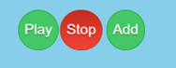

If you make more than you wanted you can simply delete the channel using the red delete button below the channel:



You can name each channel using the text boxes provided at the top of each channel strip:



Make sure to turn up the master volume before you begin creating:

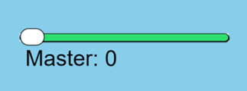

Select which instrument you want to use using the ‘synth’ slider and the below key:

0 = sampler

1 = tone synth

2 = pluck synth

3 = membrane synth

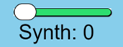

Input the desired note values into the given text boxes, using the format of note then octave i.e., C1 or G3. All boxes for all 4 channels must be filled. The sampler is based around a central note of C1:

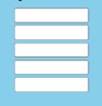

Press the ‘play’ button to hear the created audio and ‘stop’ to pause it:



**Advanced tools:**

Mono/ stereo buttons:

To select whether a track is mono or stereo simply select the corresponding button at the top of your channel:



Pan:

To change the pan for each channel, move the pan slider anywhere from -50 (hard left) to 50 (hard right) or 0 (central):



Volume:

To change the volume for each channel, move the volume slider anywhere from 0 (silent) to 100 (full volume):

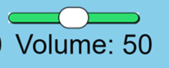

Distortion:

To add distortion to your channel, move the distort slider up from 0 (clean) to anywhere up to 100 (very distorted):

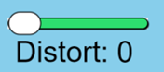

Reverb:

The reverb effect works as a bus effect meaning that to increase the room size of the reverb you increase the large reverb slider at the bottom of the page:

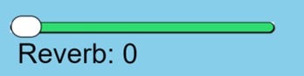

And to increase send to the reverb turn up the R.send slider on your channel:

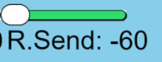

Stereo widener:

The stereo widener will affect the master output, with a value of 0 making the whole track mono and a value of 10 making the track all sides and no middle, to have a normal stereo image leave the soldier on a value of 5:

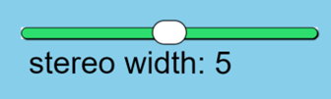

Mute:

To mute a track, press the mute button on the channel:



To unmute you can either uncheck the mute button or press the ‘Reset mute’ button above the drum buttons:



Drums:

If you're looking for some inspiration you can listen to the drum beat on the ‘play drums’ button, and can stop this sample by pressing ‘stop drums’:



**Upcoming features:**

Dynamic adding:

In future versions of UnAbleton we hope to further develop the dynamic addition of channels to allow users to have as many channels as desired, keep an eye on any future updates for these exciting additions.